IWOSC OC Satellite Meeting Notes July 1, 2015

Independent Writers of Southern California (IWOSC) www.iwosc.org
Host: Andrea Ring aring633@gmail.com 714-606-1738
http://iwoscoc.weebly.com

IWOSC NEWS
- IWOSC Reads Its Own: August 2

OTHER STUFF
- NYC Midnight Flash Fiction Challenge 2015 http://www.nycmidnight.com
- The dangers of writing groups, and a refresher on giving and taking critique.
- 5,000 WPH by Chris Fox (book and app)
- Scribd and KU updates

BOOK FORMATTING AND DESIGN

FORMATTING BASICS
- Keep the purpose of the file in mind. It will help you make common-sense choices.
- Examine the books on your shelf.
- Know your strengths and weaknesses. Make a checklist. Hire out/trade services for what you’re not good at.

FORMATTING A MANUSCRIPT FOR AGENTS
- Follow the guidelines on their websites.
- Times New Roman or Courier 12 pt font
- Double spacing
- 1” margin on all sides
- Header should include page number, author last name, and title of book in CAPS
- Start new chapters on a fresh page, about 1/3 of the way from the top. Begin the body of the chapter four lines below the chapter # and title.
- Indent five spaces at the start of each paragraph.
- Justify margins with hyphens.
- No front or back matter necessary.

FORMATTING A BOOK FOR EREADERS
- Follow the instructions given for each platform.
- Use the template, then you can convert the file using Calibre, Scrivener, or Adobe Acrobat.
- Start with title, blurb, TOC, chapter 1. Put front matter at the back. For platforms with a preview function, this allows readers to preview your writing.

BOOK INTERIOR
- The Book Designer, Joel Friedlander, says to indent paragraphs and use justified/hyphen margins.
- Use Createspace to calculate book and margin sizes (you don’t have to publish with them to get this info).
- NO HEADER on front matter, title page, first page of chapters.
- Software (from worst to best): Word, Pages, Scribus, InDesign.
- If you’re doing more than the basics, considering hiring this out.

COVER DESIGN
- www.thebookdesigner.com
- www.canva.com
- http://bookcoverarchive.com
- http://www.casualoptimist.com
- http://bookcoversanonymous.blogspot.com
- E-books and physical books have different needs.
- Typography vs. Image

From Joe Konrath’s Blog: WEDNESDAY, MAY 13, 2015
On Book Designing
Joe: What is it a book designer does?
Rob: More than anything a book designer is a problem solver… not that the authors and publishers we work with are problems. What I mean is that all books have a logic to them, so our process always begins with trying to understand what the author is trying to say. Matching a look to that message—within the realm of what’s possible with ebooks—is sometimes the hardest work we do. Obviously, some books are straightforward so our work follows suit. But more and more we find that authors and publishers are trying to push the boundaries of what we've come to know an ebook to be.
Joe: What’s different about the work you do, and me just uploading my MS Word doc to KDP?
Rob: Word is a perfectly fine presentation application, but behind the presentation is a lot of complex code. The more you fiddle with the presentation, the more likely it is you've introduced an enormous amount of inefficiency in the code, as well. For example, the Track Changes feature—while a decent way to manage the editing process—can be brutal to the code.

We've developed custom tools that extract the text from the document to leave us with super-clean code. Once we have that, we can do just about anything we want with it.

Joe: Can you show us an example?
Rob:

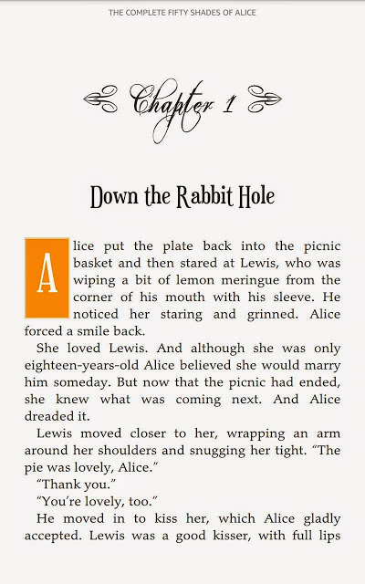
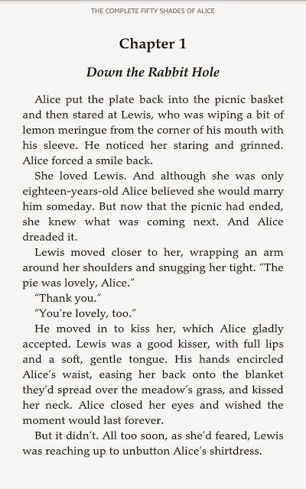

This particular treatment—which was a premium project—uses embedded fonts and a stylized drop cap to get this look. That’s 100 percent text, XHTML and CSS.

Joe: What makes a finished ebook look professional?
Rob: There are lots of aesthetic things, like drop caps and embedded fonts, that add professional finishes that you just can’t do well with ebook conversion applications or that you can’t do at all with a Word-doc-to-KDP upload. But other hallmarks are typographer’s quotation marks (AKA curly quotes or smart quotes), poetry and verse that use hanging indents, and dynamic image sizing.

Joe: What’s the difference in designing the interior of an ebook and a paper (POD) book?
Rob: It can be night and day depending on the book, but the biggest difference is that designing for paper provides us with a lot of freedom and flexibility that just doesn't exist with ebooks. Paper is a larger canvas. It's fixed in size. And we don’t have to worry about the delivery device because it's the same regardless of who’s using it.

We started as an ebooks-only shop and our workflow still follows that. So, if we can accomplish something in an ebook then the paper is usually a piece of cake. A lot of authors and publishers—especially in non-fiction—come to us having first made beautiful print books that simply won’t work well as ebooks, at least not without a lot of remixing or remaking the content. These are clearly cases where the print design was done in isolation with little or no understanding of the constraints on the companion ebook. Our advantage is that we work in both realms, with the ebook as the foundation.

Joe: Why is it so hard to get good formatting on certain self-publishing platforms?
Rob: There are two reasons. The first reason goes back to what I mentioned before… Word is pretty good at the presentation of text, but not so good at writing well-formed, efficient code underneath.

The second reason is that the platforms themselves are designed for basic, predictable manuscript formatting. This is good because it fits the democratic, DIY punk rock ideal that fuels independent publishing and makes it so most everyone can upload their manuscript and get a functioning ebook on the other side. But what if the manuscript isn't so basic or predictable? Or, worse, what if it is basic and it's still not converting properly?

I've been a Word power user for a lot of years and I wouldn't dream of uploading a Word doc to any of the self-publishing platforms.

Joe: What if an author with out-of-print backlist books comes to you, and all they have are their old paperbacks? Can you convert their books?
Rob: Absolutely! As you know, getting OCR output in shape is a lot of work. Because of this there’s more time and cost involved, but we've developed a thorough process to ensure these ebook projects are as clean as can be.

The first step is the scan (OCR is Optical Character Recognition) and we've partnered with the best in the business as far as I’m concerned. After that, we ensure all the italics and bold type is the way it should be. We fix any wonky formatting issues---things like section and column breaks, missed or inserted paragraph returns, and line breaks where they don’t belong. We then run a spell check to find any remaining obvious OCR artifacts. Once that’s done, we send the resulting Word file to the author to review. They can edit-in-place to clean up anything our process may have missed. Once the author's signed off, they send it back and we make the ebooks. In a few cases, authors have taken the opportunity to do a little rewriting.

Joe: Where do most DIYers go wrong?
Rob: Not having a complete understanding of the limitations of automatic ebook conversion apps. But I don’t necessarily fault them for this. There’s a lot of empowering conversation on the Internet about the facets of independent publishing. Unfortunately, a lot of it is also conflicting. I can see how someone might become frustrated when the results of automated ebook applications don’t match expectations.

Joe: If readers can change their font style and size, why are designers needed?
Rob: So 52 Novels can have fresh seafood flown in daily, buy Ferraris, and send our kids to Ivy League universities! Duh.

Seriously though, one of the advantages to hiring a professional ebook design and development shop—especially one that’s been around a while and can tame code—is that it can remove a lot of the worry over whether the book will make it through KDP/Nook Press/Meatginder intact. We automate some things where we think it makes sense… I mentioned extracting text from a document and that’s a prime example. But much of our process is bespoke-by-design because we believe it consistently produces higher-quality ebooks.

Joe: How many hours does it take to format a 90,000 word manuscript?
Rob: It depends. A standard MOBI/ePub design can be started in the morning and cross-platform tested by lunch time. If the author or publisher has used some kind of literary device—like block quotes, verse, emails/texts, and the like—the process will take more time to ensure we've handled those things properly.

Premium design projects take more time… making and acquiring assets for the project—whether it's finding fonts and navigating licensing, or making custom graphics—can sometimes add a day or two to the code whacking and testing.

Joe: What’s your normal turnaround time?
Rob: It depends on the time of year. Now that the industry has matured a little, we’re usually booking between three and four weeks out; add a week or two to that as we approach the holiday season.

Joe: Let me ask the question a different way. How long does it take, start to finish, to complete a project?

Rob: Ah. I wish there was a short, specific answer, but a lot depends on the author and the shape of their manuscript.

For example, if we deliver a first pass on the Thursday of an author’s scheduled week and they return just a few changes the following Monday morning, then they could possibly be publishing ebooks by week’s end. But if the review takes longer or if they’re submitting lots of changes—anything more than a few pages—or if they’re doing multiple review rounds then they should expect a longer turnaround.

If they have paper, then the timeline extends. We won’t start production on POD until we’ve got ebooks approved and ready-to-publish. It sounds counter-intuitive to not work on the ebooks and paper in tandem, but it actually simplifies project management to separate them. Besides, it can be a little daunting for an author to have ebooks and a POD dropped into their lap to review at the same time. Separating them in the workflow lets the project—and the author—catch a breath.

Some other things worth mentioning:

- Correx are handled first in-first out regardless of when the first pass was delivered. If someone takes two weeks to complete the review, they could find themselves three or more spaces back in their designer’s correx queue.
- We find things take a little longer when an author has never worked with us before or if they've never published at all, if only because everything is new to them.
- New authors also often discover their editing and rewriting wasn’t as thorough as they believed it was. After seeing their book in this new way, a lot of people find typos they overlooked a hundred times before.
- Authors unable to resist the temptation to revise their work during the production phase should expect both time and costs to increase. We can’t emphasize this enough: manuscripts must be final before they’re delivered to us for production.
Joe: What kind of authors do you like to work with the most? The least?
Rob: We like working with authors and publishers who remember there’s a person making their book.

Joe sez: And as people, Rob and Amy are a pleasure to work with and have my highest recommendation.

One of the jabs constantly made at indie authors is how our books are somehow not professional because we don't have a team behind us.
I'll admit that my books don't support an infrastructure of yesmen taking meetings and buying lunches for agents while renting in the most expensive real estate in the US and giving employees 401k plans and retirement packages from my royalties when they've spent an hour, tops, on one of my titles.

To paraphrase the wise sage Dean Wesley Smith, if you hire a gardener to cut your lawn, or a painter to paint your house, you pay them once for their service. You don't give them a chunk of your income, forever.

Dean isn't saying don't hire professionals. Professionals are needed to get a professional result. He's saying pay them once, not forever.

You might get a professional product by signing with a publisher. And in return, they leech off of you for years.

Or you can pay a one-time set cost, get the same professional quality, and make your work indistinguishable from what the Big 5 are doing.

Well, almost indistinguishable. Unless you're charging $14.99 per ebook novel. Then no one, not even your own mother, will be able to tell the difference between your books and one done by the legacy industry. Well, that, and the fact that when you finish your book you can release it, rather than have to wait 18 months. And that you have control over your cover art and title.

I've been saying this since 2009.
1. Write a great book and make it as perfect as you can get it.
2. Make sure the book looks great and provides a great reader experience.
3. Repeat.
If you're a polymath, maybe you can write, do brilliant cover art, edit and proofread yourself, design the interior, and do all of the marketing and advertising by yourself.
Rob @ 52 Novels‬ said...
We base all of our flat fee fiction pricing on the simplest manuscript -- no images (except the cover), no special formatting elements or literary devices ("handwritten" journal entries, simulated e-mail or text messages, lists or bullet points are a few examples of these).

The cost breakdown for our standard/a la carte files, a fiction manuscript up to 100k words with straightforward text and no special "extras" would look like this:
• $200 for the mobi file for Kindle plus the ePub file for use at Nook Press.
• $60 for an optional ePub file to use at Smashwords.
• $450 for a print-ready PDF for use at a Print On Demand distributor like CreateSpace or Lightning Source.
----------
$710

For the same title, our Premium package would include the mobi file for KDP, the ePub file for NookPress, the ePub file for Smashwords and the print-ready file -- all files would include custom-designed title page and section/chapter headers for $1000.

