IWOSC OC Satellite Meeting Notes December 2, 2015

Independent Writers of Southern California (IWOSC) www.iwosc.org
Host: Andrea Ring aring633@gmail.com 714-606-1738
http://iwoscoc.weebly.com

NEWS
- IWOSC Christmas Party December 10

DISCUSSION: Self-Publishing on Amazon Via Kindle Direct Publishing (KDP)

- Go to https://kdp.amazon.com. Bookmark this page.
  - Click the yellow Sign Up button on the left.
  - Use your Amazon account if you have one.
- Once you sign in, you’ll see your BOOKSHELF.
  - Add new titles here.
  - See all your titles here.
    - Status (Live, In Review, etc.)
    - Date submitted
    - Current price set by you
    - Button to see title on Amazon
  - Perform Book Actions (click on the three dots).
    - Edit details
    - Promote and advertise
    - Unpublish

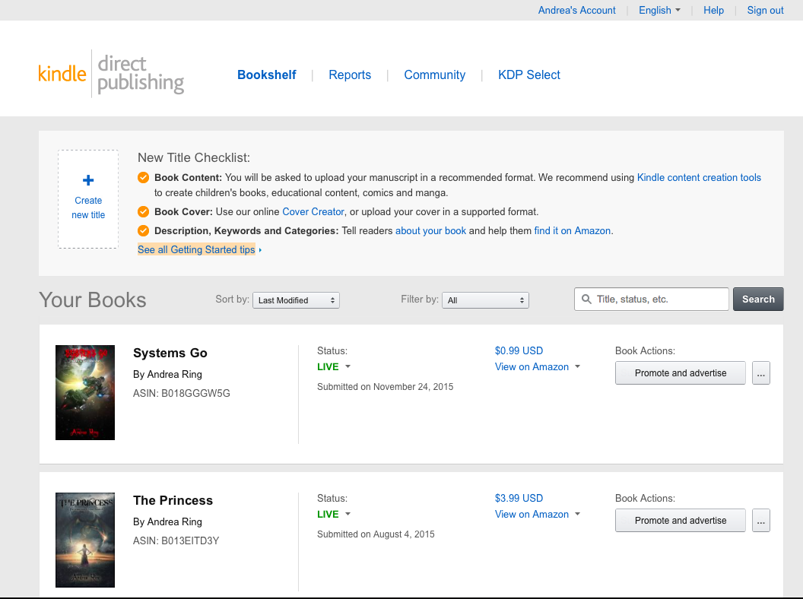
Add title
See title
Status/ Date Subbed
Book Actions
Price/ View on AZ

- New Title Checklist – What do you need?
  - Title, Subtitle (optional), Series Title (opt), Volume (# in series; opt)
  - ISBN (optional)
  - Properly formatted manuscript (see handout)
  - Book Cover (height to width ratio of 8:5; 2500 pixels x 1562 pixels)
  - Contributors (author, editor, illustrator; must have at least one)
  - Description (blurb; less than 4,000 characters)
  - Keywords
  - Categories
  - Pricing for each territory
  - KDP Select???
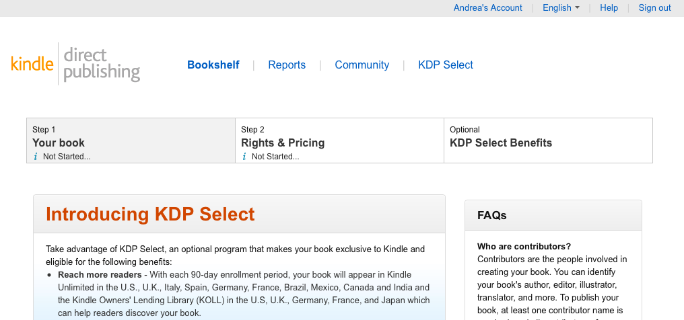

- KDP Select
  - Cons
    - You must be exclusive to Amazon. This applies only to the selected title.
    - Subscribers to Kindle Unlimited and Amazon Prime can read your titles for free.
    - You cannot make a title “Permafree.”
  - Pros
    - Higher royalty rates in 4 territories (70% vs. 35%).
    - Get paid for KU and Prime reads per page (~ $0.005/page).
    - Better visibility.
    - Kindle Countdown and Free Days promotion opportunities.
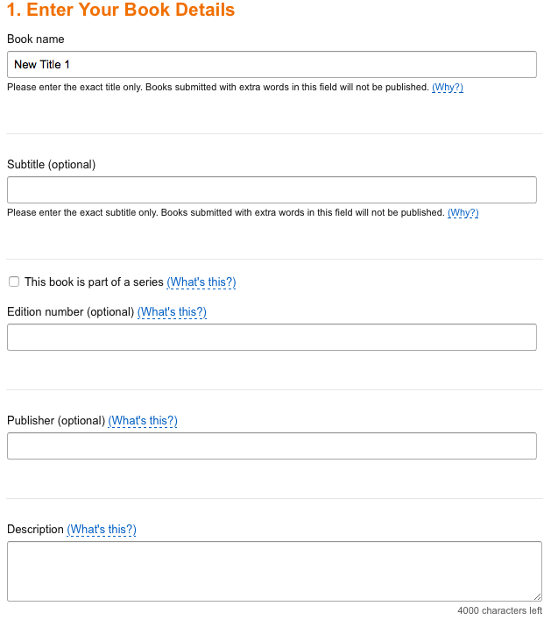

- Enter Your Book Details
  - Book Name
    - This is the title. You must enter it EXACTLY as it appears on the cover.
  - Subtitle
  - This book is part of a series checkbox.
    - Enter the exact series title. Be consistent with each subsequent book.
    - View series titles on Amazon to see how others do this.
    - If you check this box, you will also have to enter Volume. Just enter the numeral, in whatever form you choose (i.e. 1, I, One)
  - Edition number
    - This is NOT volume number of a series!
    - Use only for major updates/revisions. I recommend leaving blank for first editions of fiction.
  - Publisher
    - Use only if you have set up a publishing company.
  - Description
    - This is the book blurb. It can be quite long.
    - Readers use this as a substitute for reading the back of a book before buying. So make it exciting, leave the reader wanting more, and make sure it’s error-free!
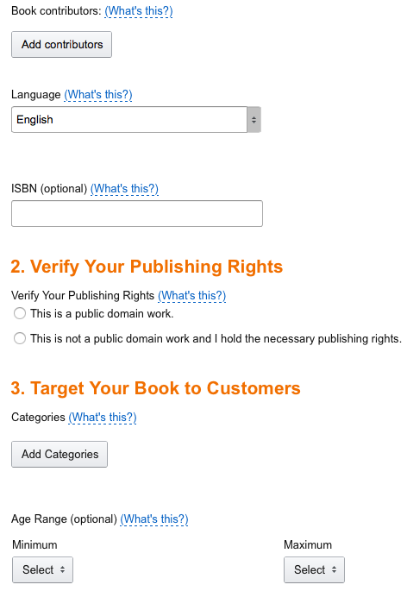

  - Book Contributors
    - Author, Illustrator, Editor, etc.
  - Language
    - English is the default
  - ISBN
    - Optional
    - You can buy them from Bowkers.
  - Verify Your Publishing Rights
    - If you wrote this work and hold the copyright, choose This is not a public domain work.
  - Target Your Book to Customers
    - Categories
      - https://kdp.amazon.com/help?topicId=A200PDGPEIQX41
      - To get into Teen/YA cats, use Juvenile.
      - Be accurate and specific. Imagine someone searching for your type of book – where would they look?
      - This is the key to bestseller rankings.
      - You may need to use keywords to get into cats.
    - Age Range
      - ONLY use for teen/children’s books
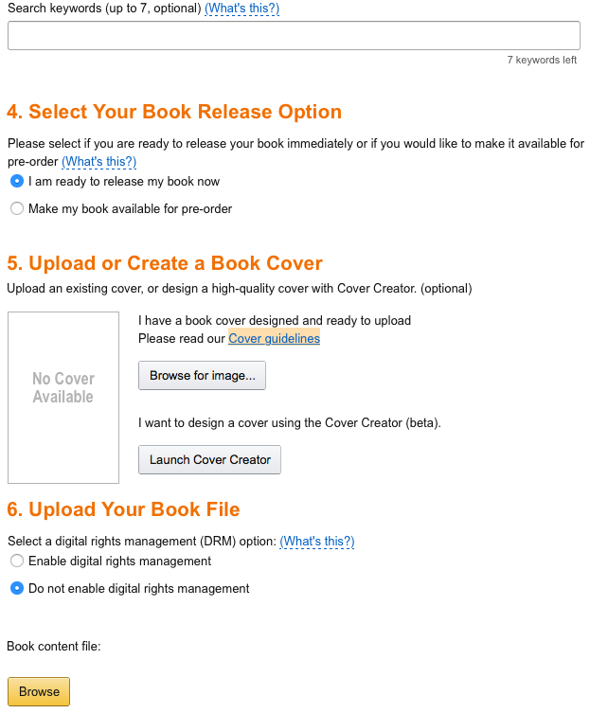

    - Keywords
      - What would a reader type into the search box?
      - Use phrases, not just words.
      - Use keywords to get into Kindle Book cats.
- Select Your Book Release Option
  - I am ready to release my book now.
    - Does not necessarily mean NOW – you can enter details without releasing your book.
  - Make my book available for pre-order
    - Best if you have a platform/readers waiting for the book.
    - Strict rules and deadlines.
    - Gets you a rank immediately on day one, but ranking may fall quickly if there aren’t a lot of follow-on sales.
- Upload or Create a Book Cover
  - Click for Browse for image… if you have one (TIF or JPG)
  - Launch Cover Creator to create one.
- Upload Your Book File
  - I recommend DO NOT ENABLE DRM.
  - Bets results with a .MOBI file. You can also upload a Word doc or .HTM file.
    - Use Calibre (free) to convert to .MOBI.
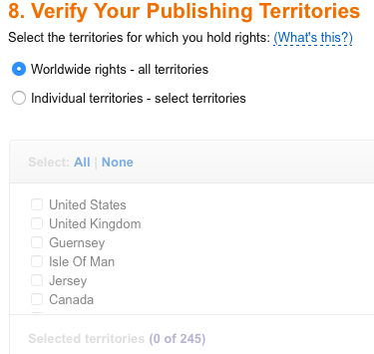

- Set Your Pricing and Royalty
  - 35% royalty for books priced $0.99 to $2.98 and over $9.99
  - 70% royalty for books priced $2.99 to $9.99
  - Some territories only 35% unless you’re in KDP Select
  - You can’t price at $0.00 (or less than $0.99), but Amazon will price match.
  - You can change price at any time.
  - Remember economics! As price increases, demand drops. Experiment. Look at what other books in your genre are priced at.

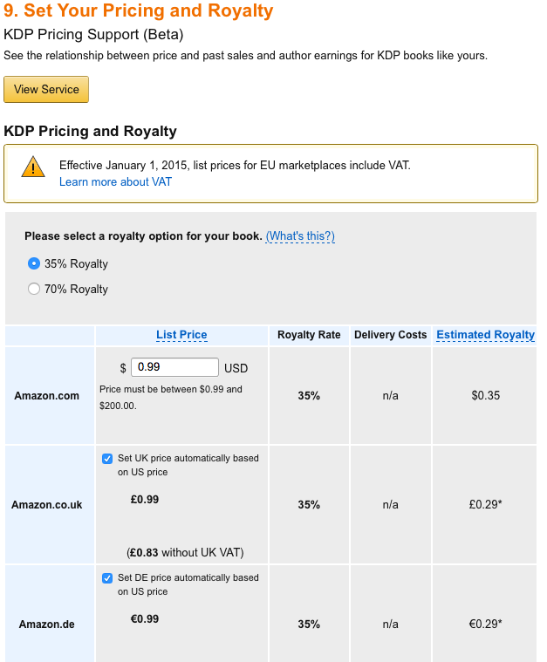

- Kindle MatchBook and Lending
  - MatchBook allows you to provide the ebook at a discounted price for readers who have purchased your paperback.
  - Prime members and Kindle owners can loan/borrow books. It’s up to you to allow this.
- DO NOT HIT Save and Publish until you are ready!!!!

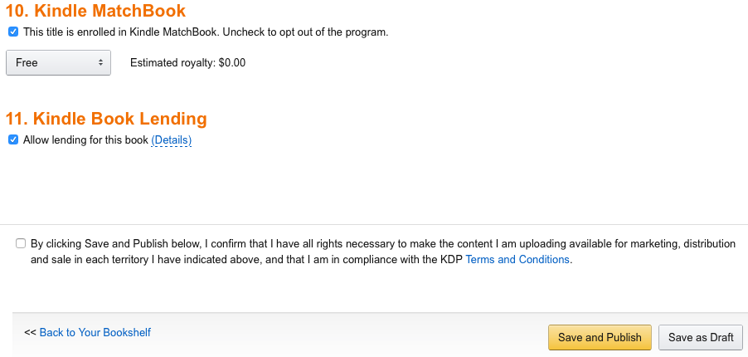

- Getting paid
  - By EFT, wire transfer (in some places), or check.
  - Funds are paid sixty days after the end of the month. Each territory pays separately.
  - $0 threshold for EFT, $100 for check.
- FAQs!
  - Can you upload a new manuscript once a title is published?
    - Yes!
  - Can you change the cover once a title is published?
    - Yes!
- How do I format my manuscript?
  - https://kdp.amazon.com/help?topicId=A12NQC9HQPI9CA
  - Use Styles!
  - Single spacing, no running headers, no page numbers
  - Think about how to read an ebook – you scroll through it, you can change font size and type. Nothing is static.
  - Links, links, links!
  - Look Inside! can be your friend – or your enemy. Use it well.
    - Put unimportant matter at the back.
    - Start with the title, author, and the blurb.
- Use Author Central.

